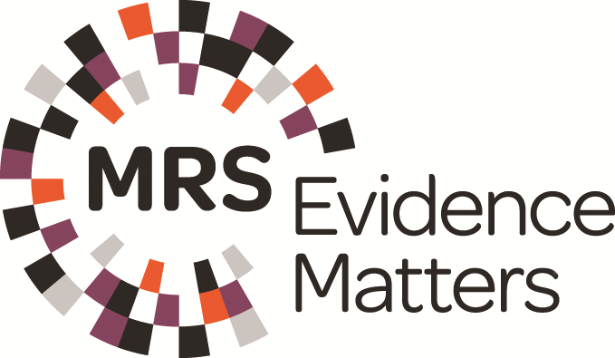
New Consumer Insights

Entry Form

Title/Project name
As it should appear in any publicity.

Name of organisation(s) entering
As it should appear in any publicity.

Primary contact details
Please supply contact details for the primary contact who takes responsibility for this submission.

Name:

Company:

Job title:

Email address:

Address for correspondence:

Postcode: Country:

Telephone:

Confirmation
As primary contact, I confirm that:

All statements made in the submission are a true and fair representation of the work carried out.
Permission to enter the Awards has been obtained from all parties involved in the research.
I understand that by entering the Awards I grant MRS permission to publish the submission.
I have read and agreed to the Rules of Entry.
I have attached the company logo(s) in the required format.

Data Protection: The Market Research Society processes the information provided by members and non-members to enable it to carry out its activities in accordance with its objectives and for its administrative purposes. We may use the information to tell you about our other products and services. We may also make it available to any person on request to enable them to contact you for any purpose other than direct marketing. If you do not wish the information to be disclosed in this way, please notify us in writing. The Society is occasionally approached by other organisations who wish to engage in direct marketing to its customers. If you do not object to the Society disclosing the information it holds for these purposes, please tick the box .

Date:

Payment details
Invoices will be sent after the closing date. Entries will be withdrawn if payment is not received by the 1 September 2017.

Entry Fees:

MRS Member/Company Partner
£500 + VAT (£600)
£250 + VAT (£300) per additional entry (in any category)

Non-Member
£750 + VAT (£900)
£250 + VAT (£300) per additional entry (in any category)

Please use the primary contact details for invoicing purposes

PO number:

NOTE: PO NUMBERS CANNOT BE ADDED RETROSPECTIVELY. IF YOU REQUIRE A PO NUMBER ON YOUR INVOICE YOU MUST ADD IT AT THE TIME OF SUBMISSION.

Name:

Address:

Postcode: Country:

Email:

Telephone:

Rules of entry

- Entries are welcomed from individuals, teams or client/agency partnerships, but you must nominate a primary contact on your Entry Form who will take overall responsibility for the entry.
- The primary contact must ensure that permission to enter the Awards is obtained from all parties involved including any clients or suppliers.
- Entries must not overtly ‘sell’ any organisation.
- Submissions may be entered for more than one Award but must be tailored to meet the requirements for each specific category.
- MRS reserves the right to re-assign an entry to another category if it is deemed more appropriate.
- The judges’ decisions are final. The judges will not enter into correspondence about why an entry is not selected as a finalist.
- By entering the Awards, you grant MRS and our media partners permission to publish your submission to promote our awards schemes and excellence in market research. If your submission contains sensitive information, you will be given the opportunity to redact this before publication. This is a condition of entry.
- Entries must be received by 10am on Monday 10 July 2017 to qualify.

One ticket to the Awards Dinner on 4 December will be allocated per shortlisted entry. Additional tickets can be purchased nearer the time at the standard advertised price.

Please send this form, along with your Submission Document and logo(s) to researchawards@mrs.org.uk.

These two forms constitute your award application and must be sent as Word attachments in an email with New Consumer Insights Award Entry in the subject line.

Please be sure to save a copy of both forms for your records.

The Market Research Society, 15 Northburgh Street, London EC1V 0JR (Registered office). Company limited by guarantee. Registered in England No 518685. VAT GB 239 8954 04.

